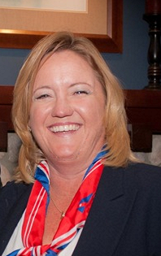

BIOGRAPHY

Sandra Sherman
Vice President & Manager
Trust Project Management & User Support
530 B Street
San Diego, CA 92101
Phone: (619) 230-4945
Email: Sandra.Sherman@unionbank.com

Sandra Sherman is Vice President and Manager of Trust Project Management & User Support. Her group supports both Institutional Services and Wealth Management as part of Global Treasury Management.

Sandra’s responsibilities cover 2 areas;
The Project Management group that is responsible for the Business analysis and Project Management Implementation for all projects that the group supports. The approximate annual project budget is 2 million dollars, not including the in-house developer hours. The Trust User Support group is responsible for the User Administration of approximately 30 different trust specific systems. Additionally they are the Customer (both internal & external) Service Helpdesk for the Trust systems.

Sherman has been with the Bank since 1996, originally hired to participate on the system merger team of Union Bank and Bank of California. Since then she helped create the Project Management role for Institutional Services, which has grown into the Trust Project Management Group. Approximately 8 years ago, she was asked to take on the management of the Trust User Support group as well.

Prior to joining Union Bank, Sherman spent 9 years at North American Trust, serving as Vice President and Manager of Trust Operations and held various other roles within the department with increasing responsibility. Sherman earned her Bachelor of Arts in Business Management from Pepperdine University, and Masters Business Administration from San Diego State University. She serves on the Board of Southwestern Yacht Club and resides in San Diego.

