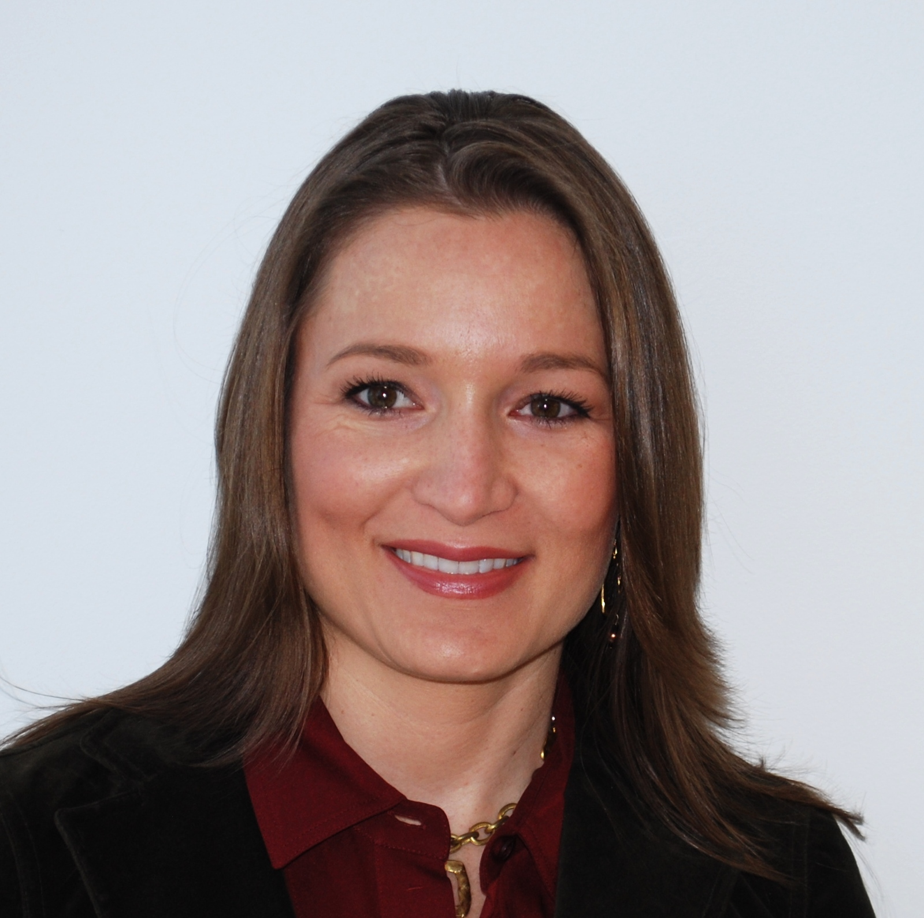

Ellen Zentner
Senior Economist, Bank of Tokyo-Mitsubishi UFJ, Ltd.

Ellen Zentner is the Senior U.S. Macro Economist for Bank of Tokyo-Mitsubishi UFJ, Ltd. (BTMU) in New York, where she is responsible for monitoring and forecasting the U.S. economy. Prior to joining BTMU in 2003, Ms. Zentner served as a senior level economist for Carole Keeton Strayhorn, Texas State Comptroller.

Ms. Zentner has received numerous industry awards for accuracy in forecasting, including Bloomberg’s list of top 10 forecasters, and serves on the prestigious Blue Chip Survey of professional forecasters. She appears regularly on Bloomberg, CBS Evening News, and CNBC to provide economic commentary and her comments can be found in publications such as the New York Times, Financial Times, and the Wall Street Journal.

Ms. Zentner conducted her B.A. and Master’s work in economics and econometrics at the University of Colorado.

