Charles ("Chip") Roame
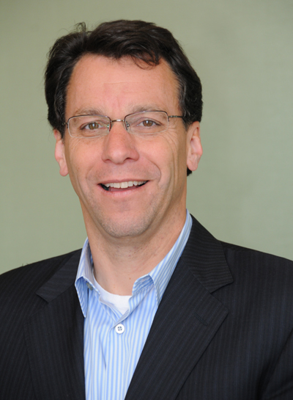
Charles ("Chip") Roame is the Managing Partner of Tiburon Strategic Advisors and a leading strategic consultant to CEOs, other senior executives, & boards of directors in the brokerage, investments, banking, & insurance markets. Prior to forming Tiburon in 1998, Mr. Roame served in similar capacities, first as a management consultant at McKinsey & Company, and later as a business strategist at The Charles Schwab Corporation. Mr. Roame is quoted daily throughout the media and, due to Tiburon's widely shared research, he may be the most frequently demanded conference speaker. His particular expertise is that of corporate strategy for larger financial services firms, designing broad multi-faceted strategies and making trade-offs between alternative businesses, products, & markets.
At Tiburon, Mr. Roame has responsibility for all of the firm's consulting, research, & marketing activities which keeps him on the leading-edge of strategic initiatives in the industry's fastest growing businesses - mutual funds, exchange traded funds, separately managed accounts, hedge funds & other alternative investments, financial planning, wealth management services, life insurance, annuities, family office services, online financial services, and the growing independent advisor markets. He has also taken a substantial interest in financial services industry venture capital & private equity opportunities and investment banking transactions. At Tiburon, Mr. Roame has led over 1,300 client engagements for over 300 corporate clients since 1998.
Mr. Roame has won numerous awards throughout the consulting and financial services industries, including being named one of the power 25 elite by Investment News, one of the twenty-five most influential people in financial planning by Investment Advisor magazine, & one of the five experts with the answers by Boomer Market Advisor. Tiburon has also been named one of the fastest growing companies by the San Francisco Business Times in multiple years.
Mr. Roame is frequently sought as a board member by Tiburon client company boards. He presently serves as a board member at Envestnet (NYSE: ENV). In the past, he has served on a variety of other boards, including those for start-up ventures Anira Advisory Group, One Harbor, & Prima Capital Holdings, the SA Funds mutual fund family, and Institute of Investment Management Consultants trade group.
Mr. Roame is a native of Detroit and a graduate of the University of Michigan (MBA) and now lives in Belvedere, CA, less than a mile from the firm's main office. Chip can be reached at CRoame@TiburonAdvisors.Com or 415-789-2541.

